**Exercise No:1**

**Date:12/10/2020**

**Aim:** Write a Python program to print the calendar of a given month and year.

**Program:**

import calendar as cal

year=int(input())

month=int(input())

if(year>999 and year<10000):

if(month>0 and month<13):

print(cal.month(year,month))

else:

print("Invalid Input")

else:

print("Invalid Input")

**Link:**

<http://103.53.53.18/mod/vpl/forms/edit.php?id=229&userid=1782>

**Output:**

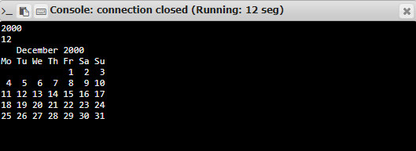

**Result:**

The program was executed successfully and the output was verified.